Kingdom of Saudi Arabia  Ministry of Education  Eastern Province Education Department  Tarbeat Al-Ajial International Schools |  |  |  |  |  |  | Date: ……/………/..………  Subject: Computer  Grade: G7
……………… |  | Seat Number |  | ……………………………………….. |  |  |  | Student’s Name
2nd Semester Exam (1St Session) 2025/2026
Sign. | Consultative Name |  | Sign. |  | Corrector’s Name | Marks in letters |  |  | Marks  in numbers
 |  |  |  |  |  |  |  |  | 40
Question A: write the correct name of each part.
Text | Video | Image


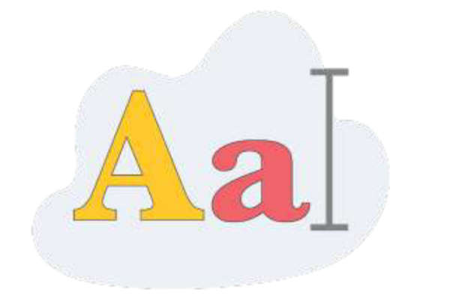

Question B: State whether the statements are (True/False).
- We use the internet every single day.
a. True b. False
- Devices need an internet connection to perform any task online.
a. True b. False
- The internet is the collection of data.
a. True b. False
Good Luck

Question C: write the correct name of each part.

10000 | 1111101 | 110010000 | 1011000
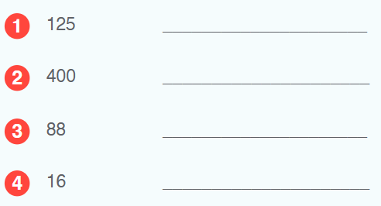

Question D: write the correct name of each part.

110 | 219 | 255 | 136
